**Table 1. Landscape attributes and diversity and aggregation estimates for each meadow**. Fetch was estimated by XYZ. Beta … The total number of epifaunal species observed in each meadow (gamma.site) and the Chao estimate for site-level epifaunal richness are given. Chao estimates are based on extrapolated estimates to 2x minimum? Abundance following Chao et al (2014). Aggregation indices for all epifaunal species in the meadow (Im) with standard errors are given; meadows with significant aggregation across species are indicated in bold (95% CIs do not include 0.5) (ref). The proportion of species present in the meadow with significant I values based on Χ2 tests is also given. *For how many species? 47, or 30?*

|  |  |  |  |  |  |  |
| --- | --- | --- | --- | --- | --- | --- |
| Site | Area (ha) | Fetch | gammasite | Im | Rsite based on chao et al | Proportion of species with significant I |
| DC | 2.30 |  | 17 | 0.47  (0.34 – 0.59) | 18.2  (10.0, 26.4) | 91 |
| WI | 0.26 |  | 18 | 0.41  (0.25 – 0.57) | 19.8  (11.5, 27.8) | 83 |
| BE |  |  | 17 | 0.50  (0.34 – 0.65) | 22.2  (4.78, 39.7) | 90 |
| EI |  |  | 13 | 0.44  (0.28 – 0.60) | 12.3  (7.6, 16.9) | 82 |
| RP | 0.72 |  | 22 | **0.57**  **(0.51 – 0.64)** | 29.4  (19.6, 39.2) | 93 |
| NB | 2.70 |  | 16 | 0.46  (0.28 – 0.64) | 19.0  (10.7, 27.3) | 88 |
| CB | 0.50 |  | 14 | 0.53  (0.37 – 0.69) | 14.0  (9.0, 20.0) | 89 |
| BI |  |  | 17 | 0.38  (0.21 – 0.55) | 17.0  (12.4, 21.6) | 77 |
| CC |  |  | 10 | **0.23**  **(0.03 – 0.40)** | 9.0  (8.0, 10.9) | 67 |

**Table 2: Relative abundance of species in each meadow.** Numbers indicate the rank of abundances relative to other species in that meadow at that time. Species with significant spatial intraspecific aggregation within the meadow, estimated as Morisita’s Index, are indicated in bold. Significance determined by chi-squared tests and P < 0.05. [*I should probably make a printout of the Im results in case we do a bonferroni*] [add a symbol to indicate grazer]. Only epifaunal taxa are shown here, others not.

|  |  |  |  |  |  |  |  |  |  |  |  |  |  |  |  |  |  |  |  |  |
| --- | --- | --- | --- | --- | --- | --- | --- | --- | --- | --- | --- | --- | --- | --- | --- | --- | --- | --- | --- | --- |
| **Species** | **T** | **DC** | | | **WI** | | | **BE** | **EI** | **RP** | | | **NB** | | | **CB** | | | **BI** | **CC** |
|  |  | **M** | **J** | **A** | **M** | **J** | **A** | **J** | **J** | **M** | **J** | **A** | **M** | **J** | **A** | **M** | **J** | **A** | **J** | **J** |
| ***Crustacean*** |  |  |  |  |  |  |  |  |  |  |  |  |  |  |  |  |  |  |  |  |
| *Caprella spp.* | 1 | 1 | **1** | 2 | 9 | **5** | 2 | **1** | **4** | 1 | **1** | 2 | 11 | 11 | 6 | 3 | **6** | 4 | 14 | 4 |
| *Aoroides columbiae* | 7 | 2 | **2** | 3 | 5 | 11 | 7 | 10 | **6** | 3 | **8** | 5 |  | 7 | 8 |  | **7** | 13 | **8** |  |
| *Pentidotea resecata* | 8 | 4 | **4** | 5 | 7 | **3** | 5 | **3** | 11 | 6 | **9** | 8 | 1 | **3** | 4 | 2 | **5** | 8 | **6** | 5 |
| *Leptochelia dubia* | 9 |  | 16 | 10 | 10 |  |  | 16 |  | 5 | **5** | 7 | 7 | **5** | 12 | 5 | **4** | 2 | **4** | 7 |
| *Photis brevipes* | 12 | 5 | **3** | 8 | 4 | **7** | 6 | 5 | **7** | 9 | **6** | 9 | 5 | 8 | 3 | 8 | **8** | 5 |  |  |
| *Monocorophium achersicum* | 13 | 6 | **6** | 6 | 14 | 9 | 14 |  |  |  | **18** |  | 9 |  | 9 | 12 | 9 | 6 | 12 | 9 |
| *Amphipod E* | 15 |  | **8** |  | 18 | 15 |  | **2** |  | 10 |  |  |  |  |  | 7 |  |  | **5** | 3 |
| *Pontogeneia rostrata* | 16 | 9 | **5** |  | 2 |  | 8 | 14 | 12 |  | 15 |  | 8 | 15 | 15 | 10 | 13 |  | 10 |  |
| *Harpacticoid copepod* | 17 | 12 | 13 | 16 | 11 | 12 | 18 |  |  |  | **11** | 12 | 3 |  | 5 | 13 |  | 10 |  |  |
| *Eogammarus confervicolus* | 18 | 7 | 12 |  | 12 |  | 16 | **8** | 9 |  |  |  | 13 | 12 |  |  |  |  |  |  |
| *Ampithoe spp.* | 19 | 11 |  | 15 | 13 | 14 | 13 |  |  |  | **16** |  | 14 | 9 | 10 |  |  |  | 15 |  |
| *Balanus spp.* | 21 |  |  | 18 |  |  | 15 |  | 10 |  | **20** | 16 | 16 | 14 | 14 |  |  | 17 |  |  |
| *Cirolana harfordi* | 23 |  | 15 |  | 8 | 13 | 17 | 15 |  |  | **21** |  |  |  |  |  |  |  |  |  |
| *Pugettia richii* | 24 | 13 | 11 | 11 |  |  | 21 |  |  |  |  | 15 |  |  |  |  |  |  |  |  |
| *Pandalidae* | 26 |  |  | 14 |  |  | 20 | 17 |  |  | **17** | 10 |  |  |  |  |  |  |  |  |
| *Pagurus quaylei* | 29 | 14 |  |  | 16 |  | 22 |  |  |  |  |  |  |  |  |  |  |  | 16 |  |
| *Nebalia sp.* | 30 |  |  |  |  |  |  |  |  |  |  |  | 15 |  |  |  |  | 15 |  |  |
|  |  |  |  |  |  |  |  |  |  |  |  |  |  |  |  |  |  |  |  |  |
| ***Gastropod*** |  |  |  |  |  |  |  |  |  |  |  |  |  |  |  |  |  |  |  |  |
| *Phyllaplysia taylori* | 2 | 3 | 10 | 1 | 15 |  | 9 | 9 | **3** | 4 | **2** | 1 |  | 13 |  |  |  |  |  |  |
| *Mytilus trossulus* | 3 |  | 14 | 7 |  | **1** | 1 | **7** | **1** |  | **3** | 4 | 4 | **2** | 1 | 14 | **1** | 1 | **2** | 1 |
| *Lacuna spp.* | 14 | 10 | 9 |  | 6 | **2** | 11 | **4** |  | 8 | **12** | 11 | 10 | 10 | 13 | 15 | 10 | 12 | **7** |  |
| *Margarites helicinus* | 20 |  |  | 12 |  |  | 10 |  |  |  |  |  |  |  |  |  |  |  |  |  |
| *Lottia pelta* | 22 |  |  | 9 | 17 |  | 19 |  |  |  |  |  |  |  |  | 11 |  |  | 13 |  |
| *Haminoea spp.* | 27 |  |  |  |  |  |  |  |  |  | **19** | 13 |  |  |  |  |  | 16 |  |  |
| *Alia carinata* | 28 |  |  |  |  |  |  |  |  |  |  |  |  |  |  |  |  |  | **9** |  |
|  |  |  |  |  |  |  |  |  |  |  |  |  |  |  |  |  |  |  |  |  |
| ***Annelid*** |  |  |  |  |  |  |  |  |  |  |  |  |  |  |  |  |  |  |  |  |
| *Platynereis bicanaliculata* | 4 | 8 | **7** | 4 | 1 | **4** | 4 | **6** | **5** | 2 | **4** | 3 | 6 | **6** | 7 | 4 | 12 | 7 | 11 |  |
| *Janua pagastecheri* | 10 |  |  |  |  | 8 | 3 | 12 |  | 7 | 7 | 6 |  |  |  | 9 |  |  |  |  |
|  |  |  |  |  |  |  |  |  |  |  |  |  |  |  |  |  |  |  |  |  |
| ***Other*** |  |  |  |  |  |  |  |  |  |  |  |  |  |  |  |  |  |  |  |  |
| *Nematode* | 5 |  |  | 13 | 3 | 15 |  |  |  |  | **10** |  | 12 | **1** | 2 |  | **2** | 3 | **1** | 6 |
| *Pycnogonum sp* | 6 |  |  | 17 |  | **6** |  | 13 | **2** |  | 14 | 14 |  |  |  | 1 | 11 | 9 |  | 8 |
| *Halacard mite* | 11 |  |  |  |  | 10 |  | 11 | **8** |  | 13 |  | 2 | **4** |  | 6 | **3** | 11 | **3** | 2 |
| *Nemertea* | 25 |  |  |  |  |  |  |  |  |  |  | 17 | 17 |  | 11 |  |  | 14 |  |  |

**Table 3.** Comparisons of univariate diversity metrics over time using two-way ANOVA with site and sampling time as main effects. *P < 0.01, **P < 0.001

|  |  |  |  |  |  |
| --- | --- | --- | --- | --- | --- |
| **Model** |  | **df** | **Sum Sq** | **Mean Sq** | **F** |
| **alpha** | **Main Effect** |  |  |  |  |
|  | Site | 4 | 58.57 | 14.64 | **2.99x10-4 |
|  | Time | 3 | 53.50 | 26.75 | **6.47x10-5 |
|  | Site*time | 8 | 122.92 | 15.37 | **1.15x10-5 |
|  | Residuals | 191 | 503.41 | 2.64 |  |
|  |  |  |  |  |  |
| **H’** |  |  |  |  |  |
|  | Site | 4 | 4.41 | 1.10 | **3.48x10-5 |
|  | Time | 3 | 0.16 | 0.08 | 0.60 |
|  | Site*time | 8 | 5.43 | 0.68 | **1.06x10-4 |
|  | Residuals | 191 | 30.65 | 0.16 |  |
|  |  |  |  |  |  |
| **S** |  |  |  |  |  |
|  | Site | 4 | 1.91 | 0.30 | **4.42x10-5 |
|  | Time | 3 | 0.09 | 0.05 | 0.36 |
|  | Site*time | 8 | 1.23 | 0.15 | **9.55x10-4 |
|  | Residuals | 191 | 8.51 | 0.04 |  |
|  |  |  |  |  |  |
| **ENS** |  |  |  |  |  |
|  | Site | 4 | 3.23 | 0.81 | **1.70x10-5 |
|  | Time | 3 | 1.91 | 0.96 | *1.18 x10-3 |
|  | Site*time | 8 | 3.65 | 0.46 | *1.38x10-3 |
|  | Residuals | 191 | 26.18 | 0.14 |  |

**Figures**

**Figure 1**: Seagrass is found at the coastal margins of Trevor Channel (approximately 200m deep), one of three channels in Barkley Sound that connect freshwater sources in Alberni Inlet and Numukamis Bay with the open Pacific Ocean. Eelgrass meadows sampled during summer 2012 between Alberni Inlet (red star) and the Pacific Ocean southwest of Dodger Channel (DC). Five meadows were sampled in May, July and August (red dots), while four additional meadows were sampled once in midsummer (yellow dots).   WI = Wizard Islet, BE = Bald Eagle Cove, EI = Ellis Island, RP = Robber’s Passage, NB = Numukamis Bay, CB = Crickitt Bay, BI = Boyson Islands, CC = Crow Cove. BMSC = Bamfield Marine Sciences Centre.

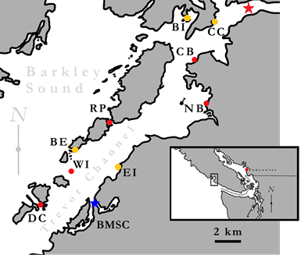

**Figure 2**: Epifaunal diversity from samples of eelgrass meadow (n = 9) of area 0.28m2 in nine meadows in Trevor Channel, British Columbia, in midsummer 2011. Asterisks indicate significant differences (P < 0.01) among sites, based on a one-way anova.

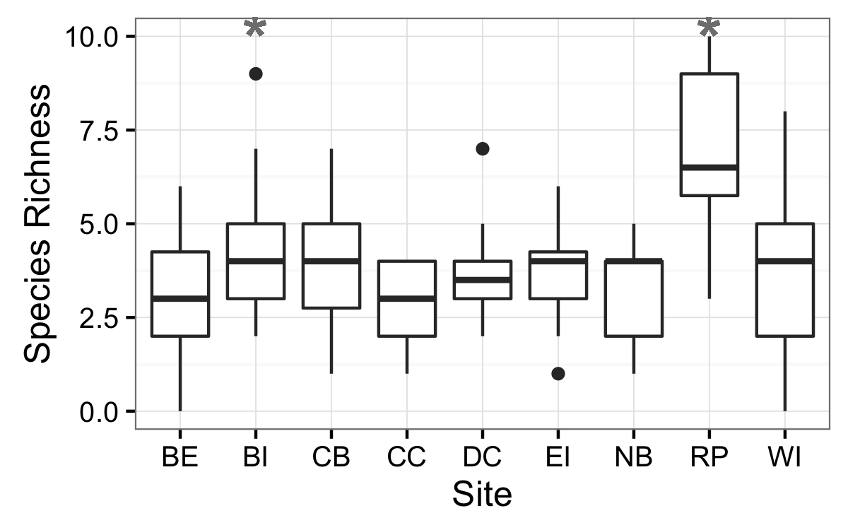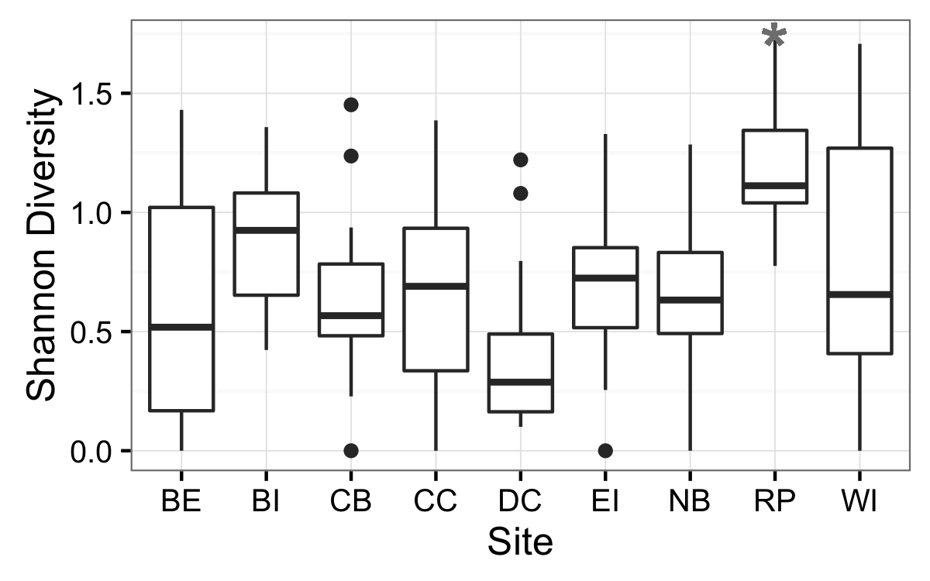

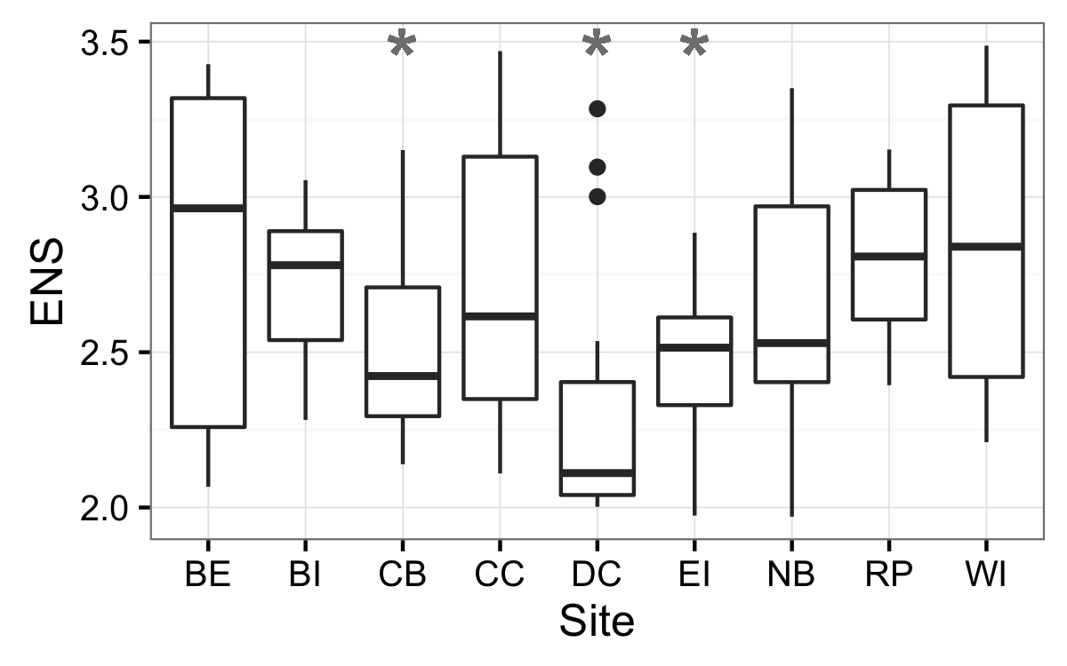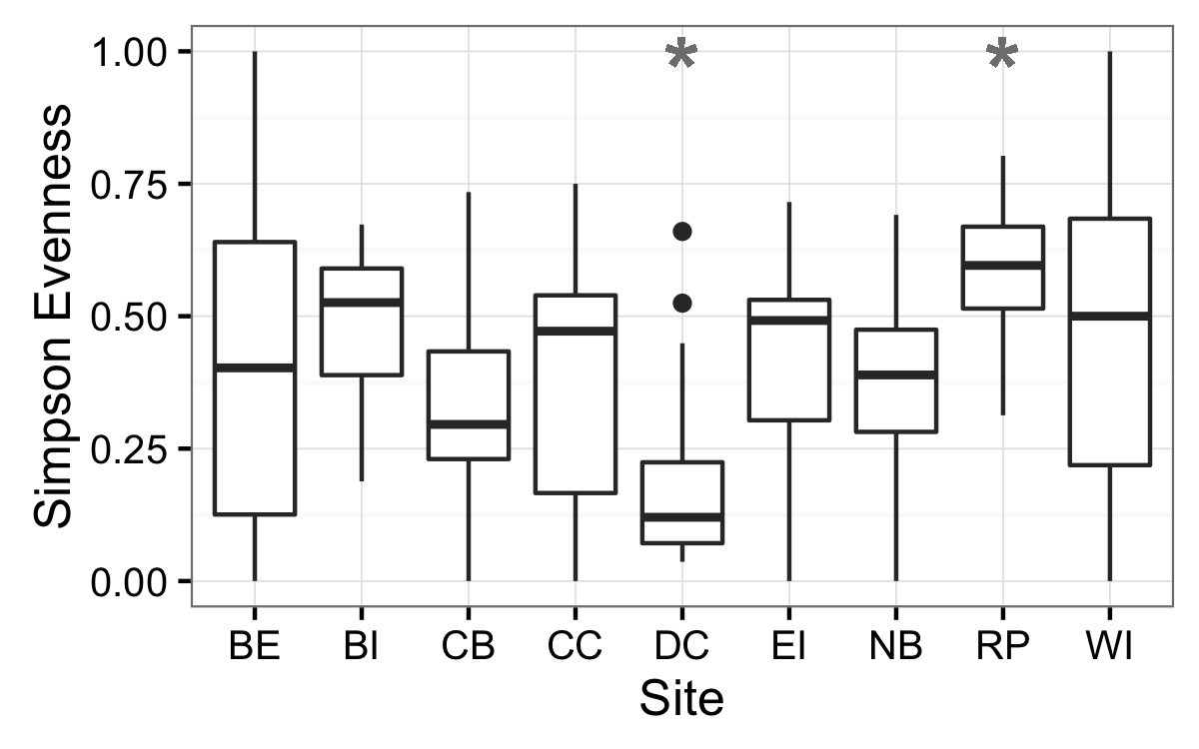

**Figure 3:** Beta diversity within all sites and time periods expressed as mean Bray-Curtis dissimilarity among plots in May (A), June/July (B), and August (C).

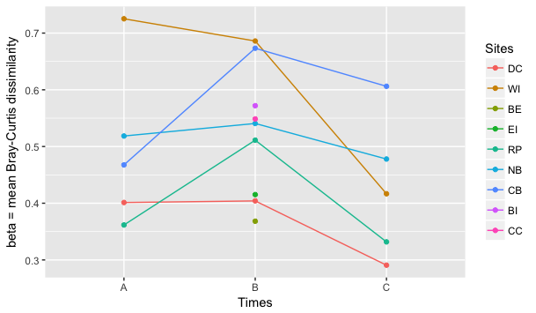

**Figure 4:** Rescaled Raup-Crick Probabilities of beta diversity or RC. Comparisons show among- and within-site probabilities for 5 (light green) and 9 (dark green) meadows. Values approaching 1 show greater dissimilarity than null predictions, values approaching -1 show less dissimilarity than null predictions, with values at 0 being no different from the null predictions.

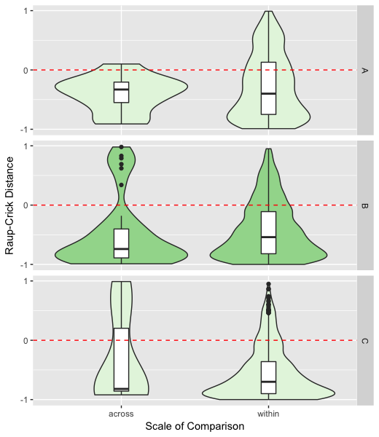

Appendix table S1

**Table A1:** Model selection results for plot-level (n = 9) univariate richness indices across nine eelgrass meadows in July 2011.

|  |  |  |  |  |  |  |
| --- | --- | --- | --- | --- | --- | --- |
| **Model** |  | **Df** | **logLik** | **AICc** | **Delta** | **wt** |
| **alpha** |  |  |  |  |  |  |
| G | Y ~ site | 10 | -271.06 | 565.8 | 0.00 | 1 |
| . | Y ~ area | 3 | -301.43 | 609.0 | 43.27 | 0 |
| D | Y ~ 1 | 2 | -302.59 | 609.3 | 43.50 | 0 |
| A | Y ~ fetch | 3 | -302.28 | 610.7 | 44.97 | 0 |
| B | Y ~ dfw | 3 | -302.51 | 611.2 | 45.43 | 0 |
| C | Y ~ dfw*fetch | 5 | -302.08 | 614.6 | 48.82 | 0 |
| F | Y ~ area*fetch | 5 | -302.14 | 614.7 | 48.95 | 0 |
|  |  |  |  |  |  |  |
| **H’** |  |  |  |  |  |  |
| G | Y ~ site | 10 | -66.12 | 153.9 | 0.00 | 0.998 |
| B | Y ~ dfw | 3 | -81.39 | 168.9 | 15.07 | 0.001 |
| F | Y ~ area*fetch | 5 | -79.57 | 169.6 | 15.69 | 0 |
| C | Y ~ dfw*fetch | 5 | -80.07 | 170.6 | 16.70 | 0 |
| D | Y ~ 1 | 2 | -83.42 | 170.9 | 17.05 | 0 |
| A | Y ~ fetch | 3 | -83.05 | 172.3 | 18.39 | 0 |
| . | Y ~ area | 3 | -83.05 | 172.3 | 18.40 | 0 |
|  |  |  |  |  |  |  |
| **S** |  |  |  |  |  |  |
| G | Y ~ site | 10 | 18.37 | -15.1 | 0.00 | 0.797 |
| F | Y ~ area*fetch | 5 | 11.18 | -11.9 | 3.18 | 0.163 |
| C | Y ~ dfw*fetch | 5 | 9.04 | -7.6 | 7.46 | 0.019 |
| . | Y ~ area | 3 | 6.05 | -5.9 | 9.18 | 0.008 |
| A | Y ~ fetch | 3 | 5.63 | -5.1 | 10.02 | 0.005 |
| B | Y ~ dfw | 3 | 5.48 | -4.8 | 10.32 | 0.005 |
| D | Y ~ 1 | 2 | 3.88 | -3.7 | 11.43 | 0.003 |
|  |  |  |  |  |  |  |
| **ENS** |  |  |  |  |  |  |
| G | Y ~ site | 10 | -52.19 | 126.2 | 0.00 | 0.493 |
| F | Y ~ area*fetch | 5 | -58.67 | 127.8 | 1.57 | 0.225 |
| C | Y ~ dfw*fetch | 5 | -59.21 | 128.9 | 2.66 | 0.130 |
| . | Y ~ area | 3 | -61.59 | 129.4 | 3.13 | 0.103 |
| B | Y ~ dfw | 3 | -63.13 | 132.4 | 6.20 | 0.022 |
| A | Y ~ fetch | 3 | -63.13 | 133.1 | 6.80 | 0.016 |
| D | Y ~ 1 | 2 | -64.88 | 133.9 | 7.62 | 0.011 |

**Table S2:** Mean shoot density and leaf area index (LAI) values with standard error (SE) for May and August 2012.

|  |  |  |  |  |  |  |  |  |  |
| --- | --- | --- | --- | --- | --- | --- | --- | --- | --- |
|  | May | | | | August | | | | |
| Site | *Mean Shoot Density* | *SE Shoot Density* | *Mean LAI* | *SE LAI* | | *Mean Shoot Density* | *SE Shoot Density* | *Mean LAI* | *SE LAI* | |
| DC | 12.3 | ±1.3 | 8037 | ±2229 | | 12.7 | ±1.9 | 7902 | ±1213 | |
| WI | 8 | ±3.2 | 3928 | ±1866 | | 7.8 | ±1.8 | 4611 | ±392 | |
| RP | 7.5 | ±2.5 | 2245 | ±5 | | 8 | ±1.8 | 4514 | ±781 | |
| NB | 6.5 | ±0.3 | 1593 | ±476 | | 9.5 | ±0.6 | 4302 | ±1216 | |
| CB | 4 | ±1 | 1903 | ±704 | | 7.3 | ±1.1 | 3562 | ±537 | |

**Table S3:** Mean temperature and salinity values with standard error (SE). need to know how many measurements, over what time periods.

|  |  |  |  |  |
| --- | --- | --- | --- | --- |
| Site | *Mean Temperature* | *SE Temperature* | *Mean Salinity* | *SE Salinity* |
| DC | 12.6 | ±0.2 | 25.7 | ±0.6 |
| WI | 13.7 | ±0.2 | 21.7 | ±0.5 |
| RP | 14.1 | ±0.3 | 22.4 | ±0.4 |
| NB | 14.9 | ±0.4 | 16.6 | ±0.5 |
| CB | 14.8 | ±0.5 | 17.3 | ±0.5 |

**Figure X.**

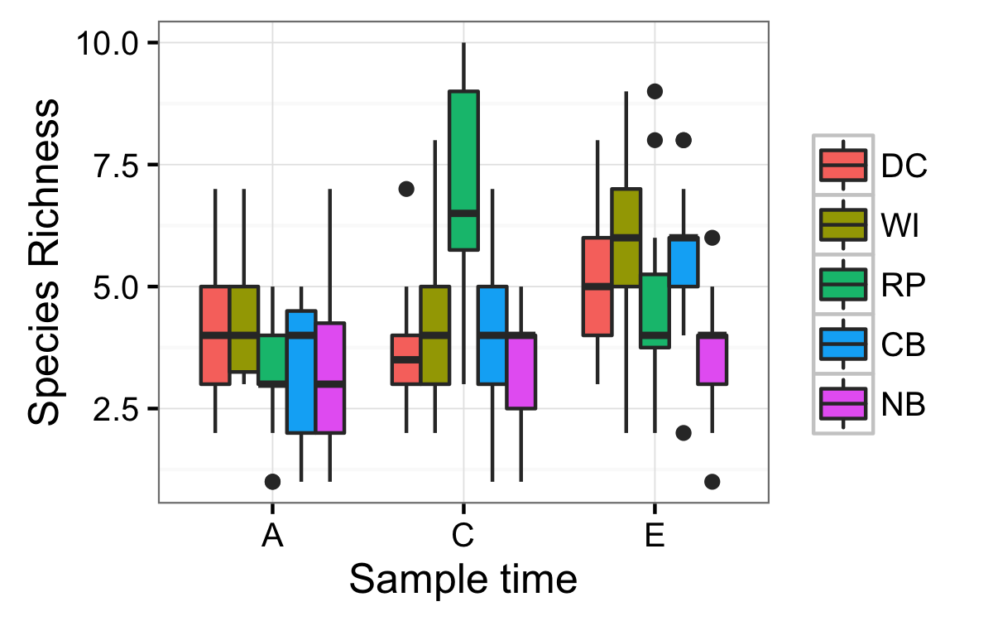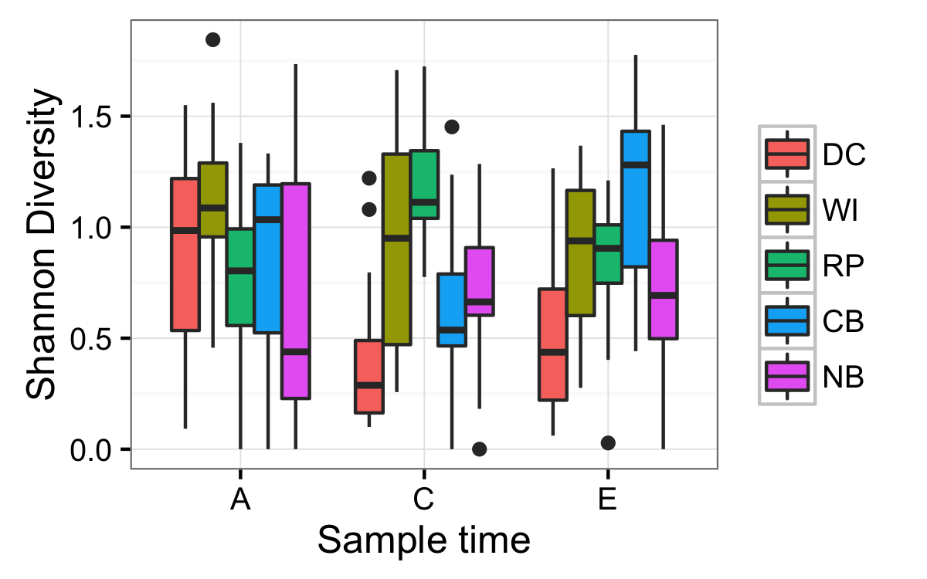

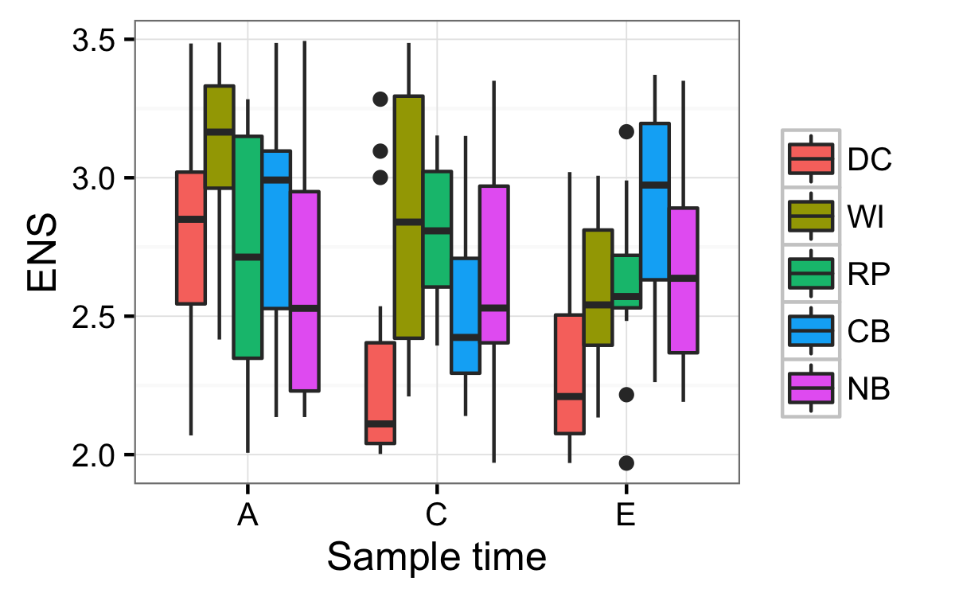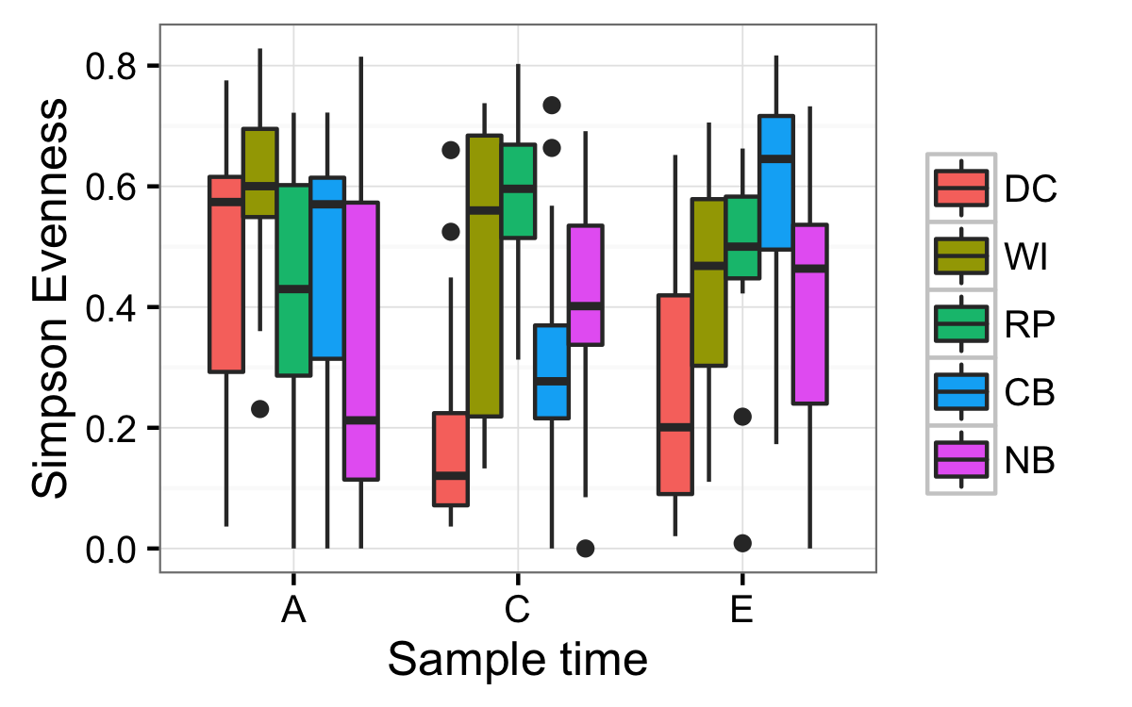

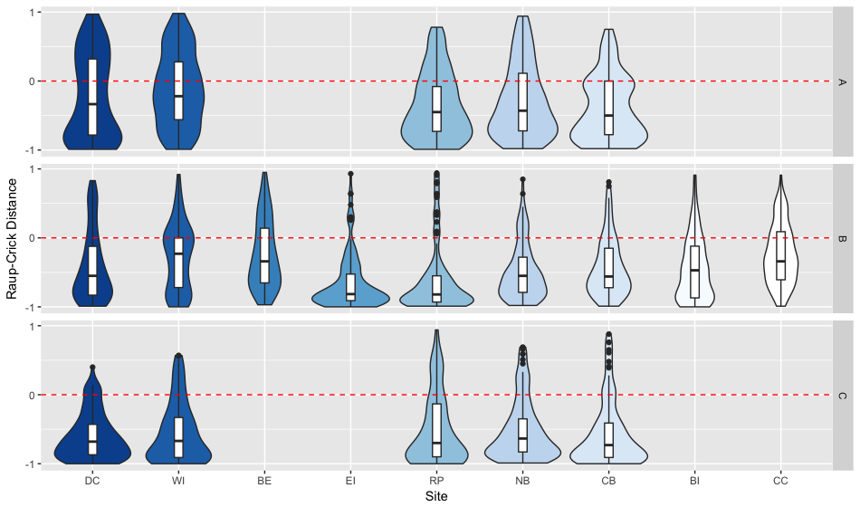**FIGURE S1: Raup-Crick dissimilarity within meadows across all sites for May (A), June/July (B), and August (C).**

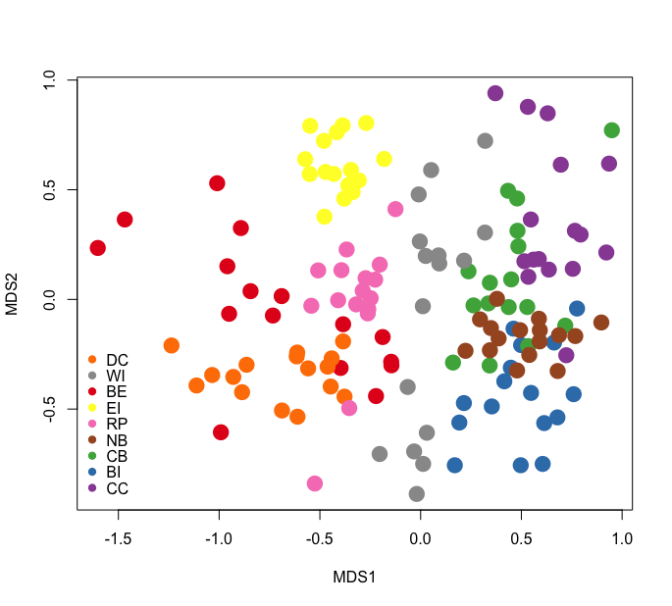

**Figure S2: nMDS of community composition and abundance in mid-summer across all sites using Bray-Curtis metric. 2-D stress = 0.23.**

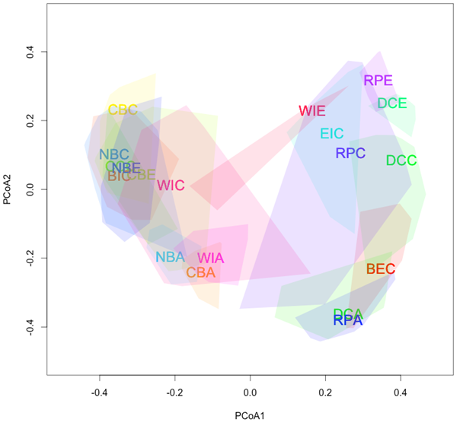

**Figure S3:** Nonmetric Multidimensional Scaling (NMDS) plot visualizing community composition across all sites and times. Polygons represent multivariate communities for each meadow at one time (n = 16 samples per meadow). Polygon area is representative of observed within-meadow beta diversity, such that a larger polygon indicates greater beta diversity among the plots sampled from that meadow. Overlap of polygons indicates similar species composition and relative abundance from plots sampled within different meadows. First two letters of polygon labels are the site codes, given in Table 1 and Figure 1, and the third letter indicates the time period sampled (A = May, C = July, and E = August).

**TABLE S3: Values of beta diversity within each site per time period expressed as gamma/mean alpha, and mean Bray-Curtis dissimilarity**

|  |  |  |  |  |  |  |  |
| --- | --- | --- | --- | --- | --- | --- | --- |
|  |  | Beta (gamma/alpha) | | | Beta (Bray-Curtis) | | |
| Sites |  | A | B | C | A | B | C |
| DC |  | 5.5133 | 5.7523 | 3.5714 | 0.4012 | 0.4041 | 0.2908 |
| WI |  | 4.4519 | 4.2950 | 2.2140 | 0.7253 | 0.6442 | 0.4167 |
| BE |  | NA | 6.0095 | NA | NA | 0.3683 | NA |
| EI |  | NA | 3.9396 | NA | NA | 0.4152 | NA |
| RP |  | 6.7528 | 2.0041 | 3.1348 | 0.3616 | 0.5112 | 0.3318 |
| NB |  | 5.8785 | 5.6306 | 4.9355 | 0.5185 | 0.5407 | 0.4779 |
| CB |  | 7.8462 | 6.6667 | 3.1566 | 0.3915 | 0.6733 | 0.6062 |
| BI |  | NA | 4.1469 | NA | NA | 0.5719 | NA |
| CC |  | NA | 7.6588 | NA | NA | 0.5486 | NA |